Healthcare in America and Developing Economies
Student’s Name
Instructor’s Name
Date

Abstract
For centuries healthcare has remained to be an utmost significant service in both industrialized as well as less wealthy economies. However, striking a balance between demand and supply is the fundamental foundation of modest economics and an efficacious business. In America, the healthcare system is experiencing a somber demand-supply predicament. Growth for health services’ consumer base, varying marketplace as well as an elderly populace has exponentially increased the demand for care in America. However, the costs for healthcare have steadily hiked on the consumers’ side and most have expressed dissatisfaction in the care they are receiving thus, putting the industry at a blink of an imminent collapse. Nevertheless, at the outset of any reality on the subject, health industry input to progress and development of any country can not be overlooked. Hence, all governments should be at the forefront of providing health amenities as well as ensuring their accessibility to citizens at affordable rates. This essay deliberates reasons behind high demand but low supply of healthcare in America and how less wealthy economies endeavor to provide healthcare to their citizens.

Healthcare in America and Developing Economies
In America, the accessibility of healthcare systems is efficient and widespread for almost every resident. Yet based on medications and hospitals, there are significant price variations for services offered. Many issues underlie America’s healthcare system, at the outset being the services are impacted by both the citizens and representatives in the political arena (Davidson et al., 2017). To successfully address lack of equilibrium in America's healthcare system, literature will critically examine the various aspects contributing to demand and the primary influences on the supply side.
Every decade the population of America is prospected to upsurge by excesses of 25 million people, despite this projected surge, the aging populace in America is indubitably advancing healthcare services demand such as cancer treatments, at the same time contributing to limited supply of healthcare specialists (Erikson et al., 2018). Equally, it is projected that between the years 2000 and 2030, America shall experience doubling of people over 65 years. It is this population which when compared to their counterparts under the same age bracket, seek healthcare services twice more, with the cancer cases skyrocketing among the elderly population than young age sets. Additionally, studies have shown that over the past one and half decades, individuals under the age set of 45 years are on the rise of expressively seeking or making physician visits (Salsberg & Grover, 2016).
Correspondingly, another potentially underlying aspect contributing to the higher healthcare demand in America is the cumulative stride of medical developments. A study established that furthermost advances in medicine greatly increased the demand for healthcare services (Sturm & An, 2014). For instance, advances in the oncology field of medicine. Nevertheless, based on this general principle, advances in medicine that avert obesity are exempted to some extent because of the rising number of health issues associated with a surge in an obese populace. Thus, as advances in the medical arena related to obesity improve, the latter may decrease demand and utilization of healthcare services to a given extent.
On the flip side, healthcare supply in America is particularly hampered by the vast number of medical professionals nearing retirement. In their place, they are substituted by a novel breed of doctors and physicians with ingrained preferences to either work as part-timers or in their esteemed specialties such as neurology otherwise dermatology, areas that are less prospective to receive responsibilities that are demanding on call. In addition, this new generation seeks to see fewer patients as they classically esteem lifestyle aspects compared to their retiring equals thus, decreasing the amount of supply (Hauer et al., 2018). In the escalating healthcare personnel, doctors represent a declining share albeit statistics from the Bureau of Labor indicating a twofold growth in healthcare-related jobs. Although a section of most health professionals such as household health aides and nurse aides could be graduated rapidly to rejoin to snowballing demands in healthcare system due to their minimal amount of training and education, this fact fails to hold for their counterparts, the physicians who spend almost two decades under training and acquiring education.
In America, the shortage of physicians counting oncologists ranges across several health specialties. This is despite the projected increase of twenty-one percent in matriculations in medical schools in the years 2006 to 2016, with the population having increased by 10 percent in a span of just concluded five years (Salsberg & Forte, 2019). Similarly, surveys have indicated lack of overall surgeons under the oncology specialty because most of them resolve to sub-specialize. According to a report dedicated to the latter preferences, it was established that 51 percent of the surgeons aimed to pursue subspecialty education while just 16 percent endeavored to enter the workforce as all-purpose surgeons (Incorvaia & Boysen, 2014). These overall surgeons greatly resolve to above career direction based on the phobia of meeting insurance perks in case of pecuniary awards of malpractice charges that are not capped by their state of operation, hence having no choice but to alter or limit practice to evade the risk of being indicted (Minkoff, 2012).
According to the projections made by Health Resources and Services Administration post considering an assortment of circumstances for forthcoming supply and demand, it is expected that a shortage of fulltime physicians shall range between 124,000 to 160, 000 come the year 2025. This shortage is bound to be relieved only if strategies would be formulated to guarantee quality healthcare accessibility along with continual reliance on recently trained physicians.
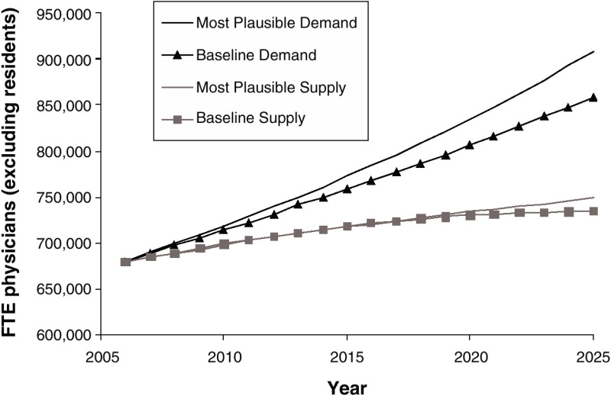
Figure 1: Anticipated full-time physicians, baseline and most plausible scenarios, 2006-2025.
Likewise, America is facing a two-decade shortage of nurses estimated to have set in at the close of twentieth century. This record shortage of nurses in over fifty years was prompted by dearth of supply that saw limited nurses entering the labor force. Over the coming decade, America's Bureau of Statistics estimates a deficit of almost a million nurses to ascent on novel professions as well as supplant retiring ones. However, based on present economic nose-dive, this rate is anticipated to drop based on an intense analysis of Registered Nurse labor market (Buerhaus et al., 2007). The analysis indicates that most registered nurses are influenced into entering the labor force by their spouses’ earnings as well as motivation from higher remunerations that greatly influence their ability to work for lengthier periods.
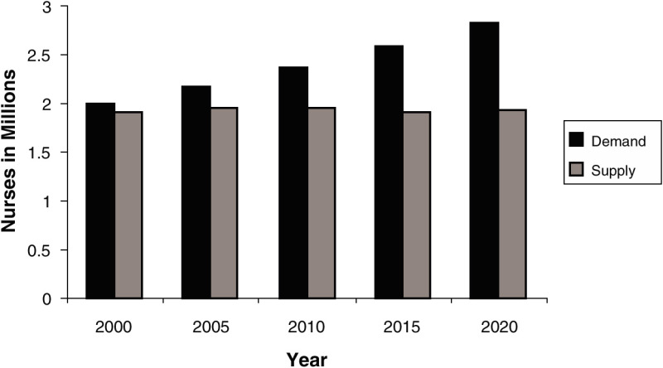
Figure 2: America faces a potential shortage of more than 1 million nurses by 2020.
In less wealthy economies, healthcare systems are developed to adapt the health economic philosophies and techniques of institutional settings of interim and developing economies such as prescribed rules like insurance laws; Informal guidelines as social beliefs and values, customs; As well as social networks besides civil society organizations (Williamson, 2015). However, these institutions vary from one country to another as well as based on time. Similarly, in less wealthy economies, matters of healthcare organization based on an industrial scale such as formulation of networks of supportive mechanisms between healthcare benefactors and health cover companies are relatively dissimilar. In this regard, the formal health cover schemes are limited to a meagre percentage proportion of the populace in urban centers.
The moral hazard problem least concern policymakers in the less wealthy economies since most healthcare financial burden is shouldered by tax otherwise patients’ straight expenditures. Thus, the primary policy problem revolves around ascertaining sponsored healthcare in government-owned health amenities besides incentive strategizing to decoy physicians to opt to work for public and shy private health centers. In addition, healthcare markets in less wealthy economies are flawed compared to industrialized countries or are absent altogether hence, it is quite common for the state to practice free or subsidized healthcare services provision. Concerning the latter contexts, quality and service accessibility dominate policy concerns of these economies rather than the moral hazard problem.
Besides these distinct properties of industrial healthcare organizations in less affluent economies, when compared to wealthy and industrialized economies, less wealthy economies’ disease load prevalence is pretty unlike (Dupas, 2017). Hence, policy-pertinent researches revolving around sound healthcare technologies that are cost-effective, mechanisms to fund healthcare as well as health specialists’ training requirements in less wealthy economies are different from wealthy economies researches, carried out on similar problems. Thus, it can be candidly concluded that health economies’ focus in less wealthy economies presents an opportunity to generate adequate information for researches. The policymakers in these economies could directly adopt findings to improve healthcare and their health systems' performance.
In conclusion, having critically examined the various aspects contributing to demand and the primary influences on the supply side, it is evident that there is need to establish the elucidations behind the heighten healthcare demand in America in face of low supply as well as direct a beam of spotlight on how less wealthy economies manage to provide healthcare to their citizens. Thus, it could be concluded that the aging and ever ballooning American population highly demand healthcare services but based on economic drawbacks as well as lack of energetic workforce to replace the retiring physicians, America stands at a blink of unbalanced supply-demand curve in her health industry. Consequently, the disparities in less wealthy economies in comparison to accomplished economies vary from country to country. However, good utilization of information generated by researches in specified economy would greatly influence the improvement of health services and systems through sound policy formulation and strategies.

References
Buerhaus, P. I., Donelan, K., Ulrich, B. T., Norman, L., & Dittus, R. (2007). State of the registered nurse workforce in the United States. Nursing Economics, 24(1), 6.
Davidson, H., Folcarelli, P. H., Crawford, S., Duprat, L. J., & Clifford, J. C. (2017). The effects of health care reforms on job satisfaction and voluntary turnover among hospital-based nurses. Medical care, 634-645.
Dupas, P. (2017). Health behavior in developing countries. Annu. Rev. Econ., 3(1), 425-449.
Erikson, C., Salsberg, E., Forte, G., Bruinooge, S., & Goldstein, M. (2018). Future supply and demand for oncologists: challenges to assuring access to oncology services. Journal of oncology practice, 3(2), 79-86.
Hauer, K. E., Durning, S. J., Kernan, W. N., Fagan, M. J., Mintz, M., O’Sullivan, P. S., & Reddy, S. (2018). Factors associated with medical students' career choices regarding internal medicine. Jama, 300(10), 1154-1164.
Incorvaia, A. N., Ringley, C. D., & Boysen, D. A. (2014). Factors influencing surgical career decisions. Current surgery, 62(4), 429-435.
Minkoff, H. (2012, October). Fear of litigation and cesarean section rates. In Seminars in perinatology (Vol. 36, No. 5, pp. 390-394). WB Saunders.
Salsberg, E., & Grover, A. (2016). Physician workforce shortages: implications and issues for academic health centers and policymakers. Academic Medicine, 81(9), 782-787.
Salsberg, E. S., & Forte, G. J. (2019). Trends in the physician workforce, 2006–2016. Health Affairs, 21(5), 165-173.
Sturm, R., & An, R. (2014). Obesity and economic environments. CA: a cancer journal for clinicians, 64(5), 337-350.
Williamson, O. E. (2015). The new institutional economics: taking stock, looking ahead. Journal of economic literature, 38(3), 595-613.

